### BENCH TOP ELECTROPLATING EQUIPMENT

For plating Gold, Rhodium, Silver & other metals

## MICROPLATE

##### The perfect machine for small scale production ,R&D and repairs

###### Completely integrated unit



Automatic heating, adjustable 20 -80ºC 0 - 10 volt,10 amp power supply



1 litre polypropylene process tanks Platinised and Stainless steel anodes Corrosion resistant case and lids Supplied with full instructions



Size: 48 wide x 25 high x 35 cms deep. 110 and 220/240 volt models 7.5 amperes. Nett weight 8 Kg. Model No 3001D

Options: MICROAGITATOR No 1385D, for thicker deposits that take several minutes process time, fitted with rotating cathode connection and digital ammeter for accurate micron thickness plating.

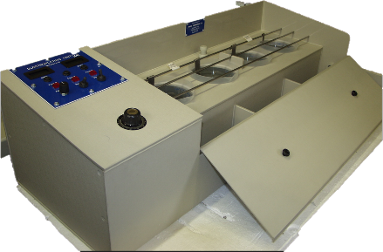Pen plating kit No 3021D, for selective plating, plugs into MICROPLATE dc outlets. See page 2.

## GRS range

*For the larger producer with*

*higher throughputs*

###### Completely integrated unit

OPTIONS

Standard GRS units have analogue thermostats, we can supply digital thermostats for further accuracy.

Amp time meters to control the metal deposited are available.

Auto shut off timers can also be supplied if required.

Please ask us if you have any further needs as units can be customised to suit many processes.

Automatic heating, adjustable 20 -80ºC



0 - 10 volt power supply, heavy duty rated 2 or 5 litre polypropylene process tanks Platinised and Stainless steel anodes Corrosion resistant case and lids



Integral rinse tanks fitted



Automatic heating, adjustable 20-80ºC Fitted with horizontal cathode agitation Digital Amp and Volt Meters



See page 4.

***SPECIFICATIONS***

2 tank 2 litre model: Size 68 wide x 30 high x 42 cms deep. 110 and 220/240 volt models 7.5 amperes. Nett 12 Kg. Number 2488D-2 3 tank 2 litre model: Size 90 wide x 30 high x 42 cms deep. 110 and 220/240 volt models 13 amperes. Nett 14 Kg. Number 2488D

4 tank 2 litre model: Size 120 wide x 30 high x 42 cms deep. 110 and 220/240 volt models 13 amperes. Nett 16 Kg. Number 2489D

2 tank 5 litre model: Size 90 wide x 40 high x 52 cms deep. 110 and 220/240 volt models 7.5 amperes. Nett 13 Kg. Number 2466D-2 3 tank 5 litre model: Size 120 wide x 40 high x 52 cms deep. 110 and 220/240 volt models 7.5 amperes. Nett 15 Kg. Number 2466D

4 tank 5 litre model: Size 150 wide x 40 high x 52 cms deep. 110 and 220/240 volt models 13 amperes. Nett 15 Kg. Number 2464D

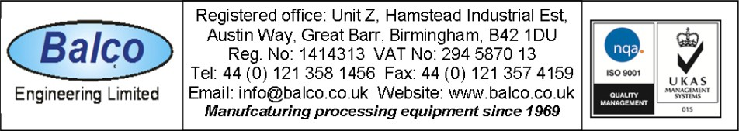

**DS 27**

**ELECTROPLATING EQUIPMENT**

For plating Gold, Rhodium, Silver, Nickel, Copper & other metals

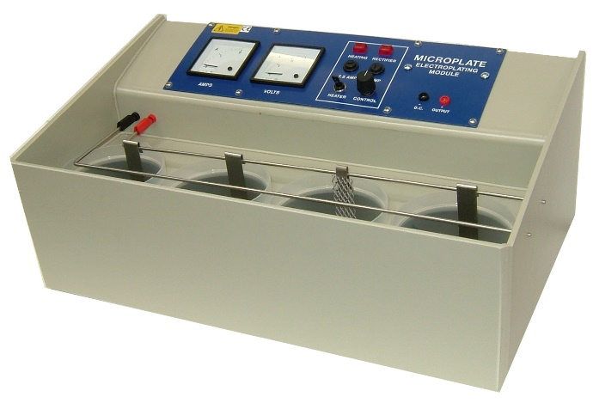**MICROPLATE**

The perfect machine for small scale

electroplating for production, research and repairs

Completely integrated unit, no external connections. Quick automatic heating, adjustable 20 - 80ºC.

1. - 10 volt,10 amp power supply, fully variable.
2. litre polypropylene process tanks with individual lids.

Platinum coated Titanium anode and two Stainless steel anodes provided. Corrosion and impact resistant case and lids for long life.

Supplied with full instructions on Gold, Silver and Rhodium plating. Over 4000 machines made over 35 years, most are still in operation. Available in 110, 220 and 240 volts a.c. supply..

Low shipping cost, packed weight only 10 Kgs. Plating pen can be connected to the MICROPLATE.

Needs only chemicals to be operational - nothing else to buy.

MICROPLATE Model No 3001D

Size: 48 wide x 25 high x 35 cms deep.

Bath sizes: 12.5 cms diameter x 13 cms deep, liquid depth 11 cm . 110 and 220/240 volt models 7.5 amperes. Nett weight 8 Kg.

Available in 4 x 1 litre and 6 x 1 litre models (4 x 1litre above)

OPTIONS:

MICROAGITATOR No 1385D, for thick gold plating, fitted with rotating cathode connection and digital ammeter for accurate micron thickness plating.

PEN PLATING KIT, No 3021D for selective plating, plugs into MICROPLATE dc outlets.

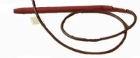

Add a tank kit for Silver plating No 3000G Rinse tanks for water, No 3000H

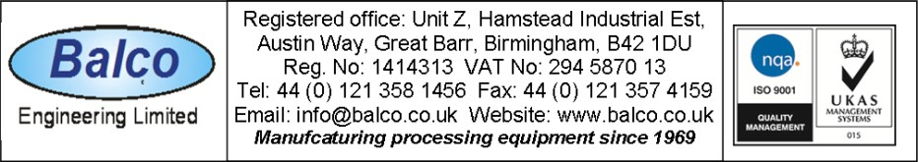

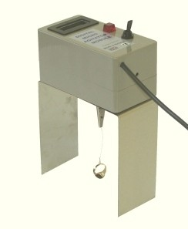

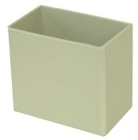

Made in Britain

**DS 27**

## PEN PLATING SYSTEMS

For the selective electroplating of Rhodium, Gold, Silver and other metals

#### THE “PEN PLATER”

###### Complete with power supply, electrolytic cleaning tank, stainless steel anode and solution holders.

Digital meter with fully variable supply.

EXCELLENT for RESTORATION WORK

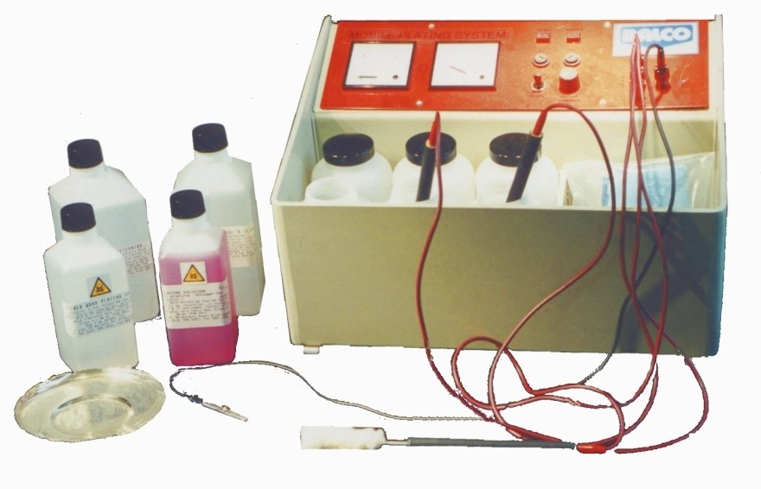**THE “WAND PLATER”**

For larger surface areas including silverware, bathroom fittings and automobile chromed areas.

Complete with power supply and 3 wands.

EXCELLENT for RESTORATION WORK

**Made in Britain**

Solutions available including white and black Rhodium, 9, 18, 22 & 24K and Rose Gold, Silver, and many others

All models come with full operating instructions

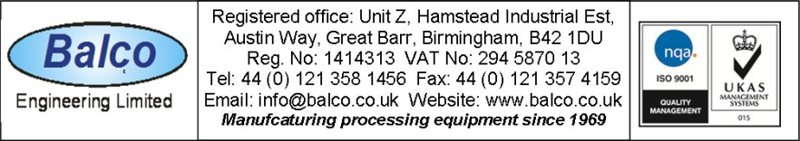**DS 27**

**ELECTROPLATING EQUIPMENT**

For plating Gold, Rhodium, Silver, Nickel, Copper & other metals

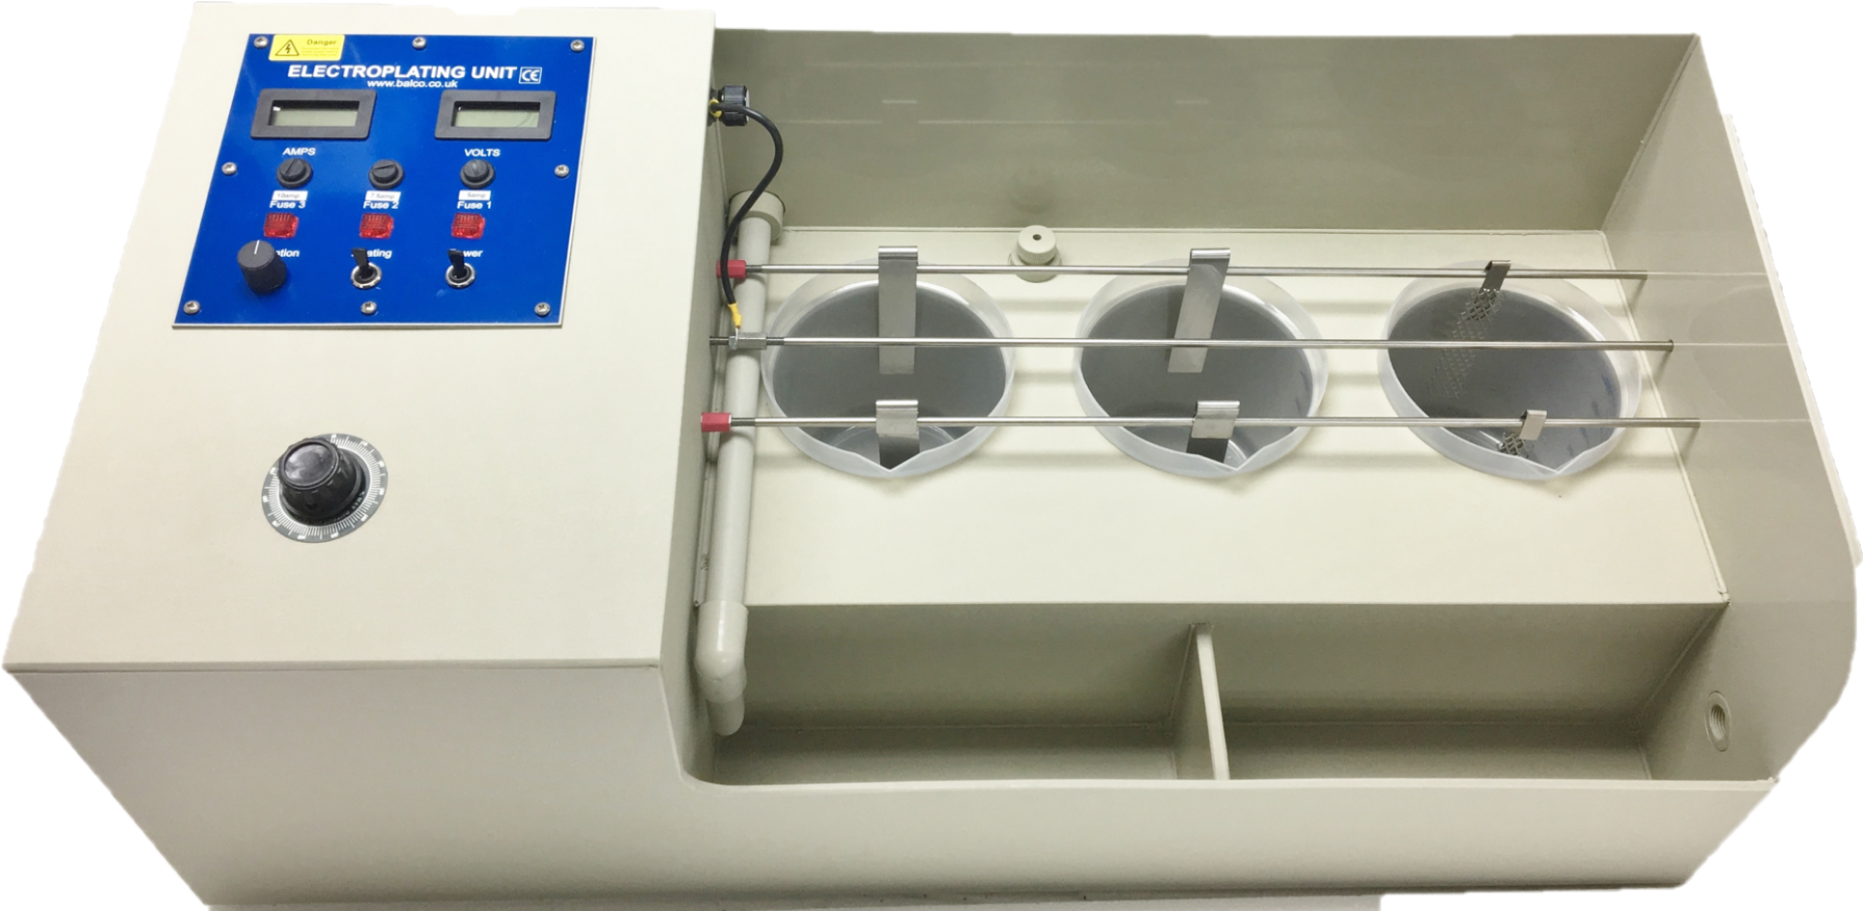

*GRS RANGE*

*Compact, self-contained, supplied with full instructions*

*2, 3and 4 tanks models as standard, others available on request*

* Completely integrated unit.
* Automatic heating, adjustable 20 - 80ºC.
* 0 - 10 volt, 20 amp power supply, heavy duty rated.
* 2 and 5 litre polypropylene process tanks.
* Platinised Titanium and Stainless steel anodes.
* Corrosion resistant case and lids.
* Integral rinse tanks fitted.
* Fitted with horizontal cathode rod movement.
* Digital Amp and Volt Meters.

***SPECIFICATIONS***

1. tank 2 litre model: Size 68 wide x 30 high x 42 cms deep. 110 and 220/240 volt models

7.5 amperes. Nett weight 12 Kg. Number 2488D-2

1. tank 2 litre model: Size 90 wide x 30 high x 42 cms deep. 110 and 220/240 volt models

13 amperes. Nett weight 14 Kg. Number 2488D

1. tank 2 litre model: Size 120 wide x 30 high x 42 cms deep. 110 and 220/240 volt models

13 amperes. Nett weight 16 Kg. Number 2489D

1. tank 5 litre model: Size 90 wide x 40 high x 52 cms deep. 110 and 220/240 volt models

7.5 amperes. Nett weight 13 Kg. Number 2466D-2

1. tank 5 litre model: Size 110 wide x 40 high x 52 cms deep. 110 and 220/240 volt models

13 amperes. Nett weight 15 Kg. Number 2466D

1. tank 5 litre model: Size 150 wide x 40 high x 52 cms deep. 110 and 220/240 volt models

13 amperes. Nett weight 15 Kg. Number 2464D



**DS 27**

# TARNISH PREVENTION SYSTEM for SILVER and SILVER PLATE

**SILVERBRITE**

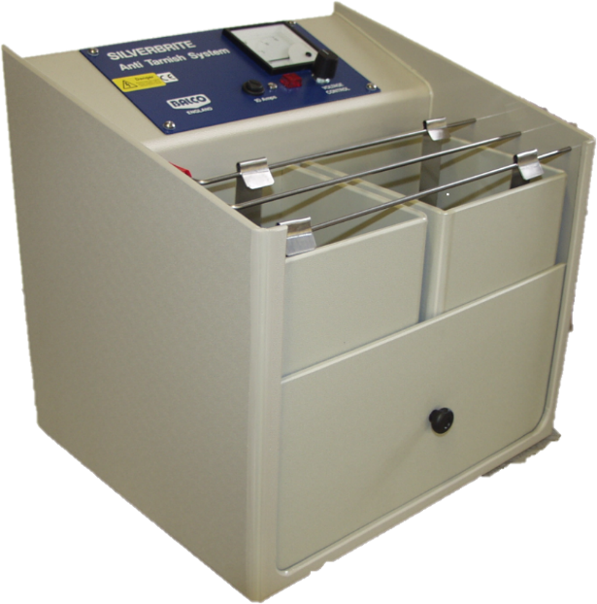

* WINDOW DISPLAYS ALWAYS LOOK PERFECT
* STOCK ITEMS KEPT IN FIRST CLASS CONDITION
* NO MORE TEDIOUS STOCK CLEANING
* LOW COST SIMPLE PROCESS
* NO SPECIAL SKILLS REQUIRED
* INVISIBLE, RETAINS ORIGINAL FINISH OF THE ITEM

The **SILVERBRITE SYSTEM** process module is a range of bench top units of 1, 5 or 10 litres capacity that connect to a normal domestic type electrical supply to generate low voltage DC power. The power generated is supplied to 2 unheated process baths that clean and protect the Silver surface in two easy stages. The fitted stainless steel electrodes cause an invisible film to build up on the surface of the silver or silver plate items rendering the top of the metal impervious to the damaging oxidation gases that are present in the air and the packaging used for display.

The **SILVERBRITE SYSTEM** is simple to use but very effective in its results, no special training is needed.

Process time is 90 seconds for 12 months display or stock protection.

This system is a miniaturisation of the industrial methods used by large manufactures and should not be confused with ineffectual immersion or spray methods.

**Note:** This unit has no heating and is only compatible with room temperature operated chemicals.

Models available

1 litre model No 3000D, suitable for small items e.g. rings, cuff links, brooches Size: 245 x 310 x 235 (Length x Width x Height ) Weight: 6 Kg

5 litre model No 3000E, suitable for items e.g. rings, cuff links, brooches, necklaces & bracelets, Size: 355 x 310 x 335 (Length x Width x Height ) Weight: 10 Kgs

10 litre model No 3000F, suitable for large output of all items.

Size: 455 x 360 x 385 (Length x Width x Height ) Weight: 16 Kgs

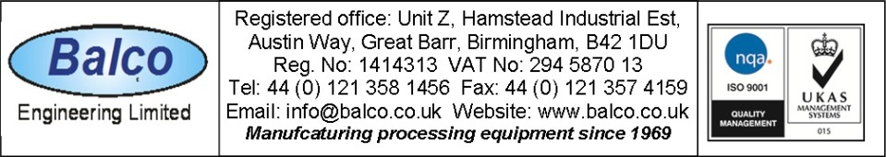

**DS 27**