# HEATED ACID TANKS

## Process units for the safe indirect heating of all acids.

Polypropylene tanks with polymer bodies, resistant to corrosion.

**NO WATER JACKETS SO NO HEATER CORROSION**

**60°C operating temperature, custom units available on request**

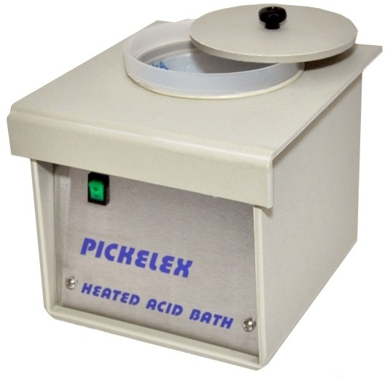

**1 litre capacity**

Internal size: 110mm solution depth x 115mm

diameter.

External size: 210 x 180 x 190mm high, 65va.

**2 litre capacity**

Internal size: 130mm solution depth x 145mm

diameter

External size: 260 x 220 x 2200mm high, 100va

**5 litre capacity**

Internal size: 230mm solution depth x 185mm

diameter at the top, tapering down to 145mm

diameter at the bottom

External size 320 x 270 x 320mm

high, 200va

# “PICKELEX”

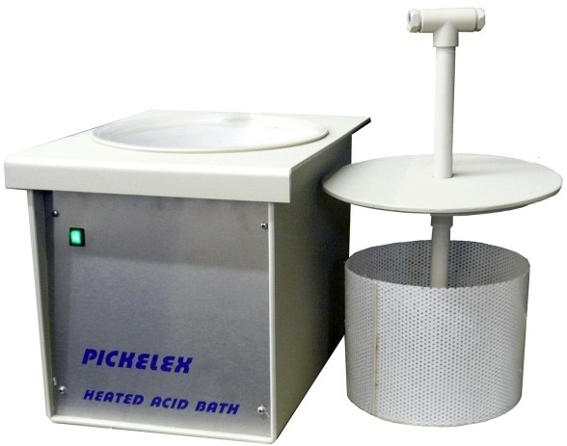

**range**

**“BASKETS”**

# “MINIPICKLE”

A range of pickling baskets, suitable for use with acids. Fabricated in stainless steel or acid resistant polypropylene.

Sizes to suit acid baths.

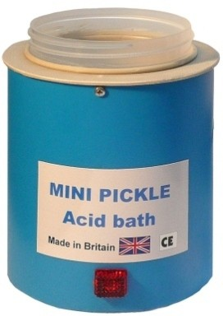

500ml capacity

Internal size 100mm deep x 75mm diameter

External size 160mm high x 120mm diameter

220/240V 20va

Supplied with lid.

For use with most acids

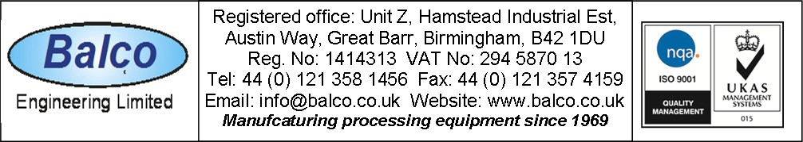

DS1