**“ROTABARREL” RANGE**

**HEAVY DUTY BURNISHING BARREL MACHINES for DEBURRING, GRINDING & POLISHING METAL ITEMS**

## Barrel burnishing or “tumbling” is a proven way to finish small components to a final finish using the minimum of labour and cost.

Water mixed with abrasives or polishes produces a real improvement to the surface of components.

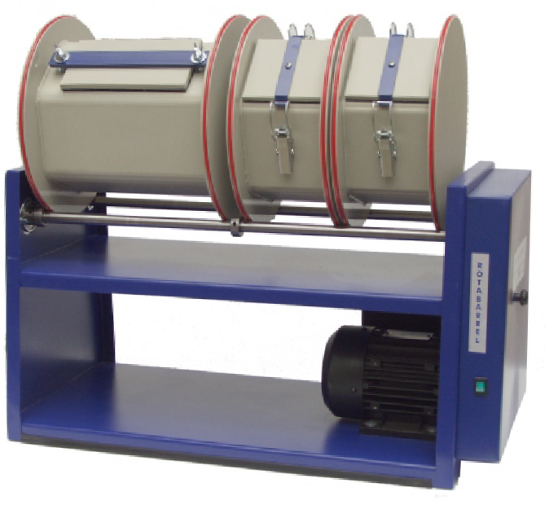To remove surface blemishes, smooth sharp edges or polish surfaces you change the media only. Works on soft and hard metals, ceramics, and plastics.

* Six sided barrel bodies for perfect results, made in polypropylene.
* 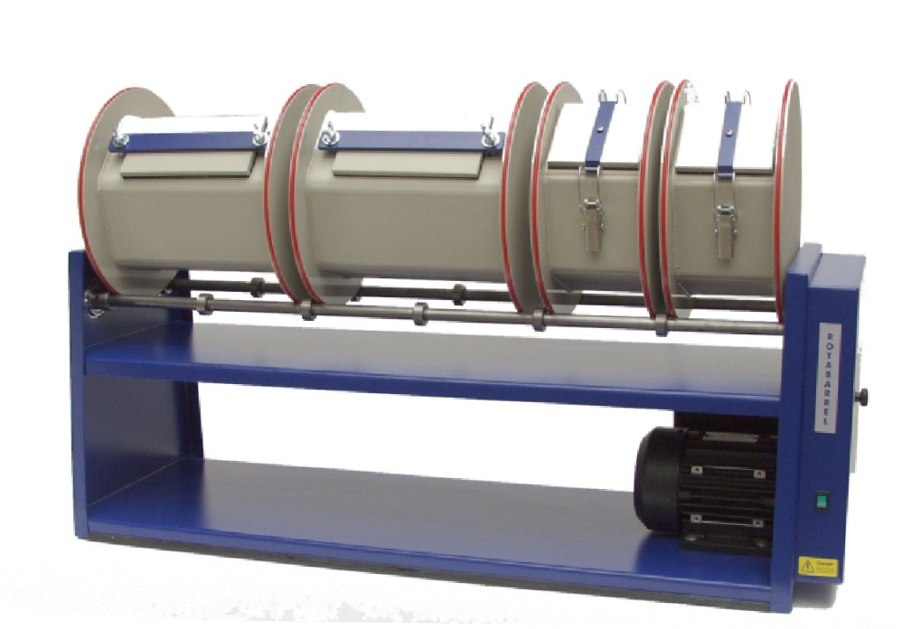New power transmission system, continuously rated.
* Quick release lid.
* Choice of barrel configurations, choose between 3 and 6 litre capacities or a mix of sizes.
* 3 sizes of ROTABARRELS to suit all your needs 6, 12 and 18

**Made in Britain**

## litre capacity.

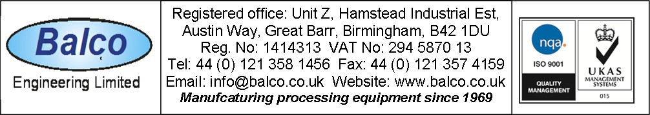DS 60

# SPECIFICATIONS

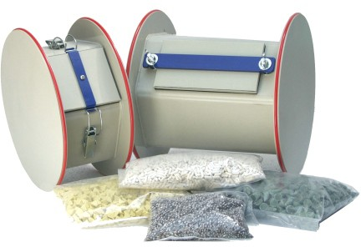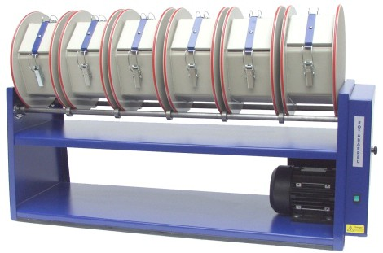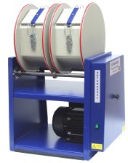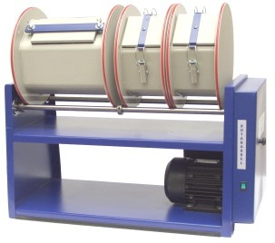

ROTABARREL 6 LITRE model, part no 4484E, Size 40 x 30 x 57 cm high 18Kg, 1.9A, 220/240 volts ac.

Supplied with 1 x 6 litre barrel body as standard.

ROTABARREL 2 x 3 LITRE model, part no 4502D, Size 40 x 30 x 57 cm high 18Kg, 1.9A, 220/240 volts ac.

Supplied with 2 x 3 litre barrel body as standard.

ROTABARREL12 LITRE model, part no 3486D, Size 65 x 30 x 57 cm high 22Kg, 2.1A, 220/240 volts ac.

Supplied with 2 x 6 litre barrel bodies as standard.

ROTABARREL 18 LITRE model, part no 3485D, Size 94 x 30 x 57 cm high 26Kg, 2.4A, 220/240 volts ac.

Supplied with 3 x 6 litre barrel bodies as standard.

Variable speed motors are available with inverter control (recommended for delicate articles)

# MATERIALS for BURNISHING

Each 3 litre barrel body requires either, 3 Kgs of Mixed shot or

1. Kgs of Ceramic/plastic deburring media.

Each 6 litre barrel body requires either, 6 Kgs of Mixed shot or

1. Kgs of Ceramic/plastic deburring media.

PRODUCTS

Mixed shot, No. 1210B1 per Kg

Polishing powder “BARRELBRITE”, use with mixed shot, No AG1450 in 1 and 25 Kg packs

Cones, green, for heavy deburring, No 1209B1, per Kg Pyramids, yellow, for medium deburring, No 1208B1, per Kg Pins, white ceramic, for finishing, No 1208B, per Kg

All deburring media is used with “Cutting Powder PB”, No 2051C in 1 and 25 Kg packs ALTERNATIVE BARRELS.

Any standard configuration can be modified by exchanging 1 x 6 litre barrel bodies

with 2 x 3 litre bodies and vice versa ( small extra charge ) or spare barrel bodies may be needed for keeping work piece types separate.

1. litre barrel body, No 4501D 6 litre barrel body, No 4503D

DS 60