**FILTAIR 2**

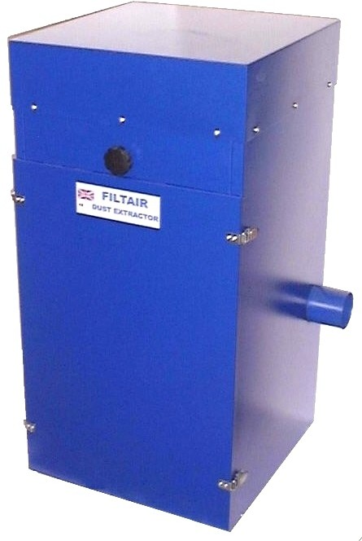**Industrial Strength Dust Extractor**

STOPS HARMFUL DUST BEING INHALED & ELIMINATES DANGEROUS PARTICLES FROM THE WORKING AREA

# Improves workshop conditions during Grinding

**Polishing**

**Lapping Sharpening Planing Routing**

**Powder handling**

The **FILTAIR 2** is a continuously rated extraction machine designed to be connected to many dust producing sources.

The **FILTAIR 2** extracts the contaminated air from the work area and passes it through re-usable fabric filters to remove the dust. Cleaned air is ducted to the rear of the machine for return to the workshop area and the residue falls into the catchment tray in the base.

***QUICK TO INSTALL AND EASY TO USE,***

***connect up the pipes, plug in and GO.***

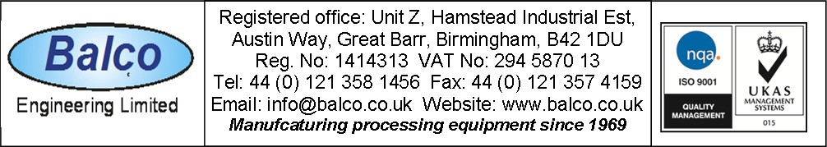

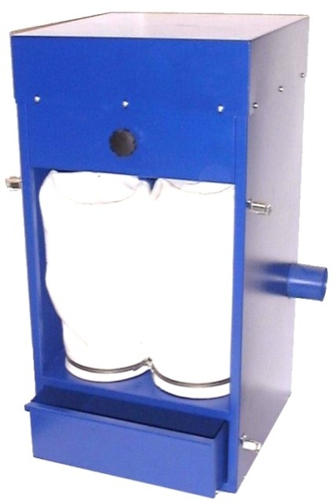

**Made in Britain**

|  |  |
| --- | --- |
|  |  |
|  |  |

DS 56

# FILTAIR 2 Dust extractor



b

a

FILTAIR

e

d

c c

## COWL SET

a = Shaker knob b = Filter cover

c = Suction inlets 75 mm Ø d = Air outlet

e = Power cable

Height floor to work top = 885 mm Maximum width = 540 mm Maximum front to rear

= 520 mm (570 mm with sound diffuser ) Weight = 42 Kgs nett

Sound level: 70dB at one metre

Extractor motor: 200cfm (.095 m²/second ) 0.5 hp (.37kw) 3.1A. IP64. Cap. 16µF

Voltage 220 - 240 volts 50 / 60 Hz Stock number: 2485D

## EXTERIOR VENT KIT

Reduces operational volume from 70dB to 65dB and vents waste air out of work area. Contains 3 metres x 75 mm pipe, clips and wall/window plate. Easy self fit. Stock No: 2485EVK

1 x Hood assembly with safety screen. 1 x Base unit. 1 x Mesh 2 x Adjustable slide runners

Height = 290 mm. Width = 135 mm

Front to rear = 240 mm. Weight = 2.5 Kgs nett Maximum wheel size 150 mm Ø x 50 mm wide. Finish: powder coated steel. Stock number: 2484D

## POLISHING MOTOR BASE

Motor base unit to bring motor height to mm

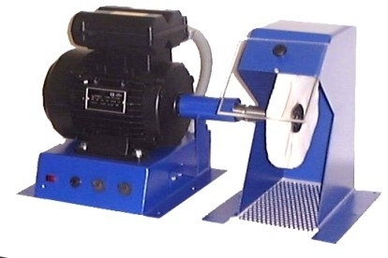With 240 volt mains switch and Motor switch. Stock No: 8835F

## POLISHING MOTORS, 240 volt single phase

0.5 hp 0.37kW, 2800 rpm with taper spindles,Double ended, Stock No: 8834E.Single ended No 8834S

1.5 hp 1.1 kW, 2800 rpm with taper spindles,Double ended, Stock No: 8835A. Single ended, Stock No: 8835S

*FITTING ACCESSORIES*

75mm Ø flexipipe, per metre. Stock number: 0129C 75mm clips, each, Stock No: 0130C

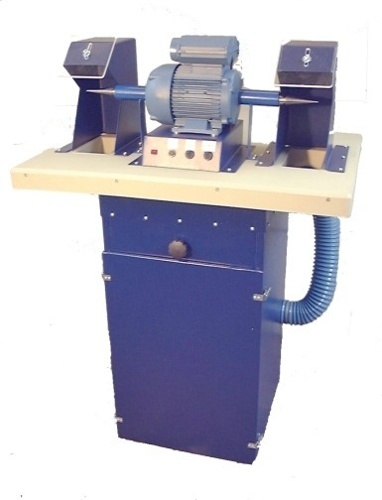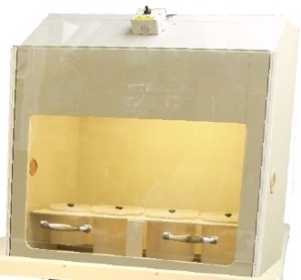

## DUST REMOVAL SYSTEM

The FILTAIR can be connected to one of our Polypropylene or Steel enclosures to create a safe working environment for the weighing, decanting and packaging of dangerous or unpleasant materials that produce dust.

Note this is a PARTICLE filter system and not intended for use with acids or solvents.

Particles are collected in the removable base tray and the air flow is filtered via 10 micron filters to remove the last traces of dust.

If the particle size is smaller than 10 microns diameter (0.001 cm) an external filter can be connected to the FILTAIR outlet to reduce the emission size to 1 micron (0.0001mm).

Please quote enclosure size and dust type for a specific quotation.

DS 56