**Industrial Strength Extracted Polishing Machine**

## STOPS HARMFUL DUST BEING INHALED & ELIMINATES DUSTY WORKSHOPS

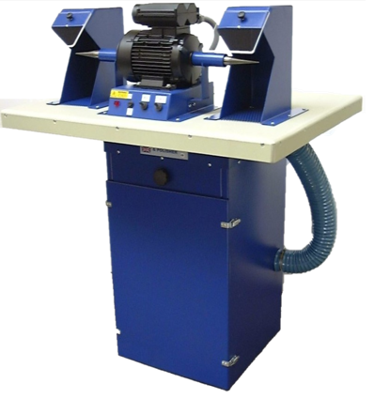

# POLIMAX ONE

**The professionals choice**

**Made in Britain**

|  |  |
| --- | --- |
|  |  |
|  |  |

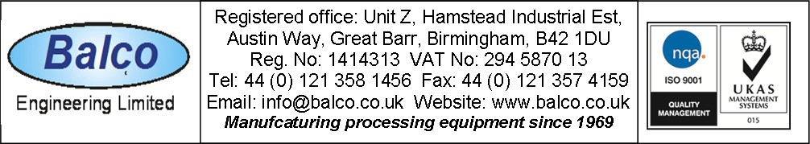

DS50

# POLIMAX 1

**polishing extractor**

## The POLIMAX 1 is a continuously rated polishing machine designed for the polishing of metal and other materials.

The extraction system sucks the contaminated air from the polishing area and passes it through fabric filters to remove the dust. Cleaned air is ducted to the rear of the machine for return to the workshop area.

***QUICK TO INSTALL AND EASY TO USE***

a = Clear safety screen

b = Adjustable cowl assembly c = Shaft guard

d = Polishing motor e = Neon light



b

b

d

c

c

m

m

k

j

n

e f g h

a

a

f = Fuse 10 amp anti-surge type g = Polishing motor on/off switch h = Dust extraction on/off switch

j = Shaker knob

k = Extractor cover

m = Flexible connection pipes n = Work top

Height floor to work top = 900mm Maximum width = 900mm Maximum front to rear = 680mm

Maximum wheel/mop size = 200mm Weight = 50 Kgs nett

Sound level: 70dB at one metre Polishing motor speed = 2800 rpm. Variable speed available by request Standard Ip54. Cap. 36µF

Polishing motor power = 1.5hp (1.15kw) 6.6A Extractor motor power = 0.5 hp (.37kw) 3.1A Standard IP64. Cap. 16µF

POLIMAX total maximum current 10 amps Voltage 220 - 240 volts 50 / 60 Hz

Also available with a variable speed polishing motor 50 - 2800 rpm

DS 50