**MICRODRY MEDIA DRYER**

Ideal for drying metal components, including delicate items - will not scratch softer metals.

Removes water without water staining. Uses no toxic materials.

Very low running costs.

Not recommended for articles with small blind recesses.

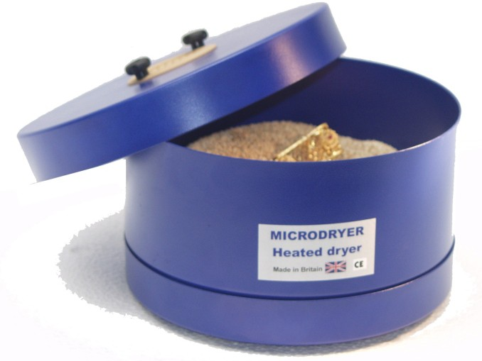

**MICRODRY**

Stock No: 2455D Diameter: 250 mm

Height: 150 mm

Power: 60vA at 240volts Supplied with drying media

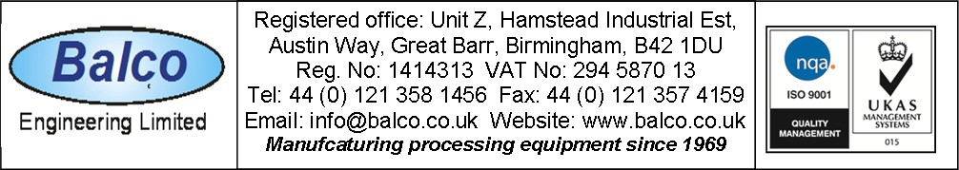DS 18